EC2 Instance Launched:
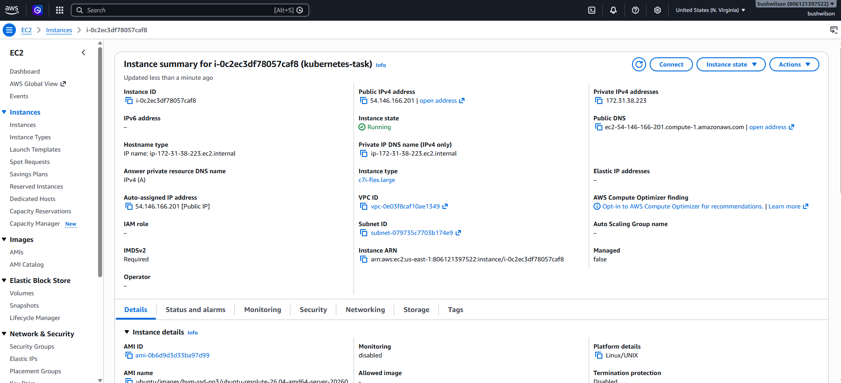

Docker Installed:
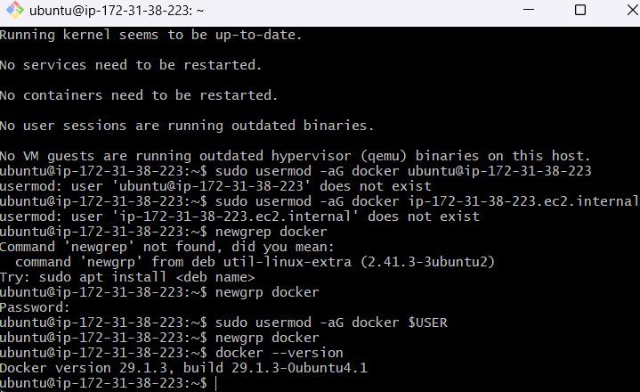

Installed Kubectl & Minikube:
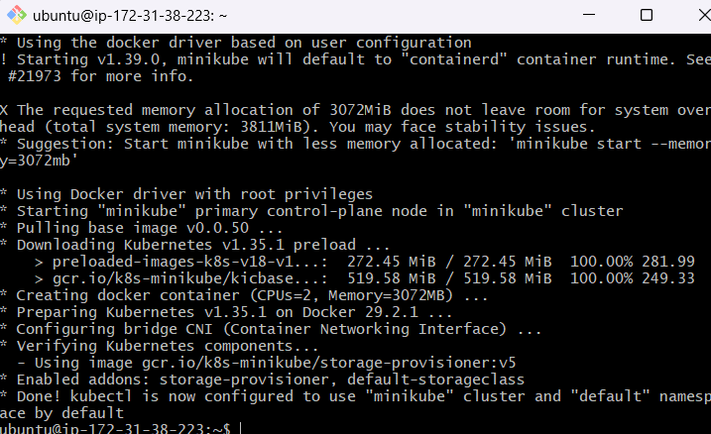

Kubernetes Default Namespaces:
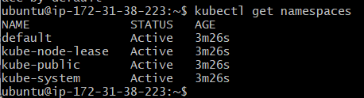

Namespace Operations:
Namespace Created – dev:
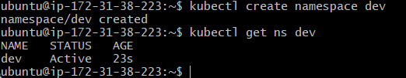

Deployed nginx pod in dev:
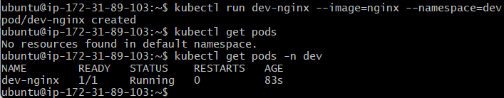
Yamal file created:
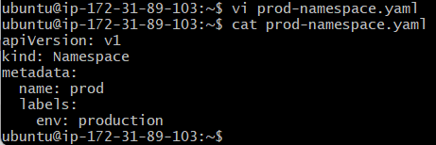
Creation with labels:
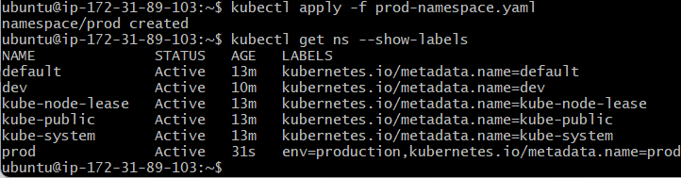
Deletion:
